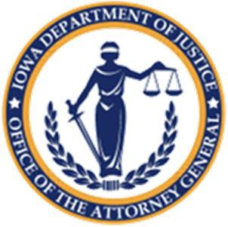
IOWA DEPARTMENT OF JUSTICE
OFFICE OF THE ATTORNEY GENERAL
CRIME VICTIM ASSISTANCE DIVISION

CERTIFICATION-CIVIL RIGHTS TRAINING

Agency Name:

Program Name:

Grant Number:

I certify that I have viewed the following Office for Civil Rights (OCR) online training modules offered by the U.S. Department of Justice, Office for Civil Rights:

Training | Date Completed
Overview of OCR and Laws Enforced
Obligations of Recipients to Provide Services to LEP Persons
Civil Rights Laws that Affect Funded Faith Based Organizations (if applicable)
Civil Rights Protections for American Indians in DOJ Funded Programs and Obligations of Funded Indian Tribes
Standard Assurance and How the OCR Enforces Civil Rights Laws

I accept responsibility for ensuring at the beginning of the grant cycle that Agency staff are trained and understand their responsibilities related to the federal civil rights laws applicable to recipients of federal funds.

Signature of Designated Civil Rights Contact Person: __________________________________________
Printed Name: ________________________________________________________________________
Date: ___________________

This form should be printed, signed and uploaded into IowaGrants.gov as part of your
grant application

