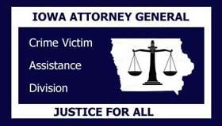

Resource Sharing Project E-Learning Course for Board of Directors Board Member Certification of Training

Agency:

Board Member Name:

Date Board Member Joined Board:

Date online Board Member E-Learning Series completed:

Agency receives STOP VAWA and/or SASP funding and Board Member completed Module 2: Section 3: 8.2. YES NO

Agency is either a statewide coalition, or other statewide agency and completed Module 1: Section 3 YES NO

I, the undersigned, certify that I have completed the online Board Member E-Learning Series located at http://www.resourcesharingproject.org/e-learning-course-boards-directors and all requirements as set forth in the above information provided.

Signature: Date:

Office of the Attorney General of Iowa • Crime Victim Assistance Division • Lucas State Office Building • 321 East 12th Street
Des Moines • IA 50319 https://www.iowaattorneygeneral.gov/for-crime-victims

